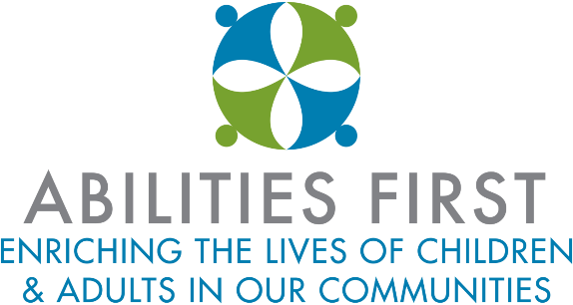

COVID-19 TESTING

As per CDC guidelines, COVID-19 testing will be ordered by a health care provider or as directed by the Department of Health. A list of facilities performing COVID-19 tests will be made available below to staff and families.

Our staff are essential workers who are encouraged to access testing. In the event a staff member is symptomatic or has been determined to have direct or proximate contact with an individual who has tested positive, they will be advised to contact their health care provider for next steps prior to returning to work. In the event any staff does not have a health care provider and needs assistance accessing testing, they will contact their Human Resource Representative who will facilitate this.

COVID-19 TESTING SITES

Pulse-MD Urgent Care
Urgent care center· Poughkeepsie, NY· In Canterbury Plaza · (845) 243-7100 Urgent care center · Wappingers Falls, NY · (845) 204-9260. COVI D-19 testing center - Appointment required· Referral not required· Testing for all patients. Instructions: Schedule a virtual visit first. Once you book your visit online, a Pulse-MD team member will contact you with instructions.

Rite Aid Pharmacy
Pharmacy· Poughkeepsie, NY· (845)471-1190 Drug store · Middletown, NY · (845) 692-2422 Drug store · Kingston, NY · (845) 340-0664. COVID-19 testing center - Appointment required· Referral not required· Testing for all patients.

Mid Hudson Regional Hospital of Westchester Medical Center
Hospital · Poughkeepsie, NY · (845) 483-5000 COVID-19 testing center. Appointment required· Referral required· Testing for all patients. Instructions: Please call the COVID Call Center at 914 202.4530 from 8:30 a.m. - 5 p.m., Monday through Friday.

Digestive Disease Center
Medical clinic · Poughkeepsie, NY · (845) 452-9800 Doctor-Fishkill, NY · (845) 896-0736
COVID-19 testing center. Appointment required· Referral required· Testing for all patients. Instructions: It is vital that you be screened through a Virtual Visit with a Northern Medical Group provider who will determine and if you are a candidate for testing. They will set up your appointment for testing: If you are experiencing a cough, fever, shortness of breath or any flu-like symptoms, you should be screened, If you have had contact with someone who has tested positive for Coronavirus, If you or a person close to you has been diagnosed with COVID-19

Community Primary Care
Medical office · Hopewell Junction, NY · In Rabi R. Sinha, M.D. · (845) 226-4590 COVID-19 testing center. Appointment required. Referral required. Testing for all patients Instructions: Seeing patients with or without insurance

Emergency One Urgent Care
Urgent care center · Hyde Park, NY · (845) 229-2602 Urgent care center· New Windsor, NY· (845) 787-1400 Urgent care center · Kingston, NY · (845) 338-5600 Walk-in clinic · Poughkeepsie, NY · (845) 330-3200. COVID-19 testing center - Appointment not required· Referral not required· Testing for all patients Instructions: You may walk in,or get in line online.

PM Pediatrics
Pediatrician · Hopewell Junction, NY· (845) 897-4500 COVID-19 testing center Appointment not required· Referral not required ·Testing for all patients Instructions: Get screened in-office or via a telemedicine visit with the PM Pediatrics Anywhere app.

CareMount Medical
Medical group · Fishkill, NY · (845) 765-4990 Urgent care center· Poughkeepsie, NY· (845) 471-3111 Medical group · Rhinebeck, NY· (845) 231-5600 Doctor-Poughkeepsie, NY - (845) 231-5600 COVI D-19 testing center Appointment required· Referral required· Testing for all patients

CVS
Drug store · Dover Plains, NY · (845) 877-6372 Drug store · Garnerville, NY · (845) 429-4794 Drug store· Newburgh, NY· (845) 566-0012 Drug store· Peekskill, NY· (914) 737-1144 COVID-19 testing center Appointment required· Referral not required· Tests limited to certain patients· Drive-through Instructions: CVS Health is conducting drive-up coronavirus testing (COVID-19). Limited appointments are available to patients who qualify. Patients must legally reside in the state where the test is given and be 18 years of age or older. Patients being tested are required to stay in their vehicles and surfaces are sanitized after each visit.

HealthAlliance of the Westchester Medical Center
Medical laboratory · Kingston, NY · (845) 303-2730 COVI D-19 testing center Appointment required· Referral required· Testing for all patients. Drive-through Instructions: Appointment only. Call (845) 303-2730 for screening Rockland Anthony Wayne Recreational Area Palisades Parkway Medical laboratory · Bear Mountain, NY · (888) 364-3065 COVID-19 testing center. Appointment required· Referral not required·
Tests limited to certain patients· Drive-through Instructions: APPOINTMENT IS REQUIRED. Individuals who would like to be tested must make an appointment by calling NYS COVID-19 Hotline 888-364-3065. NO WALK-INS allowed. All patients must remain in the vehicle.

Rockland Anthony Wayne Recreational Area Palisades Parkway Medical laboratory · Bear Mountain, NY · (888) 364-3065 COVID-19 testing center Appointment required· Referral not required· Tests limited to certain patients· Drive-through Instructions: APPOINTMENT IS REQUIRED. Individuals who would like to be tested must make an appointment by calling NYS COVID-19 Hotline 888-364-3065. NO WALK-INS allowed. All patients must remain in the vehicle.

ParCare Community-RamBam Monroe Medical clinic· Kiryas Joel, NY· (845) 472-6226 COVID-19 testing center. Appointment required· Referral not required· Testing for all patients. Corporate office · Middletown, NY · (845) 703-6999 COVID-19 testing center. Appointment required· Referral required· Tests limited to certain patients· Drive-through

Crystal Run Healthcare Corporate office · Middletown, NY · (845) 703-6999 COVID-19 testing center Appointment required· Referral required· Tests limited to certain patients· Drive-through.

Orange Urgent Care Urgent care center · Middletown, NY · (845) 703-2273 COVID-19 testing center Appointment required· Referral not required· Testing for all patients.

Middletown Medical General Hospital · Middletown, NY · (845) 342-4774 COVID-19 testing center Appointment required· Referral required· Testing for all patients· Drive-through.

Excel Urgent Care of Goshen, NY Urgent care center · Goshen, NY · (845) 360-5530 Urgent care center · Fishkill, NY · (845) 765-2240. COVID-19 testing center. Appointment not required· Referral not required· Testing for all patients.

AFC Urgent Care Airmont. Urgent care center · Airmont, NY · (845) 915-4832 COVID-19 testing center Appointment required· Referral not required· Tests limited to certain patients Instructions: APPOINTMENT IS REQUIRED. Individuals who would like to be tested must make an appointment by calling NYS COVID-19 Hotline 888-364-3065. NO WALK-INS allowed. All patients must remain in the vehicle.

Staff’s test results must be reported to Human Resources and, if positive, the Local Health Department (LHD) so the following contact tracing protocol can be implemented.

Student’s test results must be reported to the school’s COVID-19 Resource Officer: Marci Meybohm, 845-452-0774, ext 2528, or marcimeybohm@abilitiesfirstny.org.

CONTACT TRACING

Abilities First will maintain records of all staff, students and essential visitors to programs to ensure contact tracing can be effectively implemented in the event of an exposure. These records include but are not limited to:

- A daily visitor log will be kept at the reception area of each building along with the health screening questionnaire.
- Attendance records and student schedules of therapies, gym, art, etc., maintained by the teacher in each classroom.

In the event a staff or student receives a positive COVID-19 test result, the Abilities First will notify the local health department (LHD) and work collaboratively with the LHD as outlined in the following flow chart.

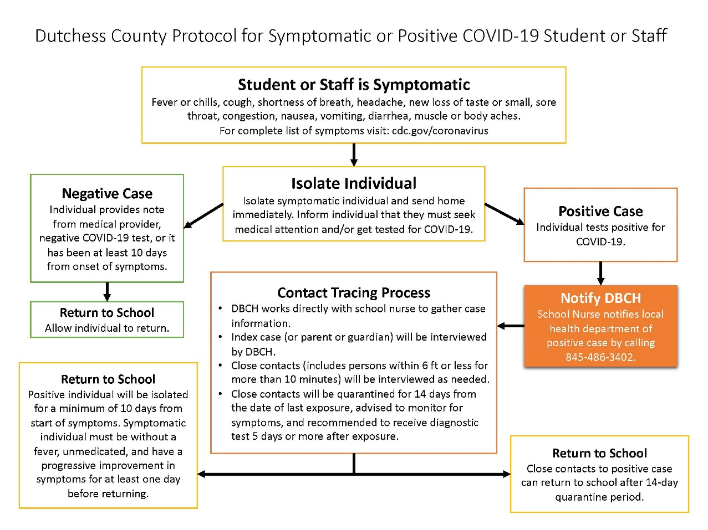

In the event Abilities First is deemed responsible for contact tracing, the COVID 19 Resource person will follow these steps:

1. For each person who is showing symptoms consistent with COVID-19 (e.g., fever, cough, or shortness of breath) identify and document the following:

- The name of the person
- The symptoms the person is exhibiting
- The date symptoms began
- Whether the person is known to have been in contact with someone who tested positive for COVID-19
- If the person traveled outside their home/residence within the previous 14 days, and if yes, where
- If the person has been hospitalized, what hospital, the date of hospitalization
- If the person has been tested for COVID-19, where was the test done and the date of the test
- Date/time test results were received, and test results (if known)
- Where the person is currently located (e.g., home/hospital) and their quarantine/isolation status

2. Abilities First COVID 19 Resource person will reach out and notify all contacts that the person had in the 48 hours before the symptoms started (or if no symptoms but had a positive test, then 48 hours before they were tested). They will be notified of their potential exposure, but identities will remain confidential.

Contacts are considered direct or proximate as follows:

- Close contact is defined as “being within 6 ft of a person displaying symptoms of COVID-19 or someone who has tested positive of COVID-19”
- Proximate contact is defined as “being in the same enclosed environment such as a classroom, office, or gatherings but greater than 6 ft from a person displaying symptoms of COVID-19 or someone who has tested positive for COVID-19”

3. Abilities First will keep a record of all contacts including:

- Each contact’s name
- Each contact’s phone number and/or email address (where they live or work)
- Date they were contacted and by who (Name, Title)
- If a contact cannot be reached or notified, Abilities First will note this on the record of contacts and contact the LHD to report this

This will be continuously updated to include the most recent DOH and CDC recommendations.

