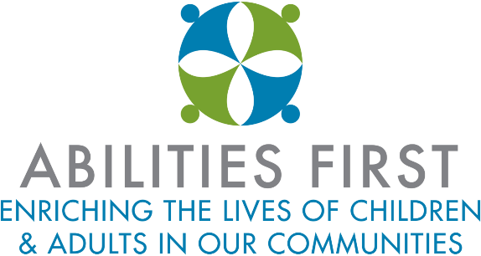

Abilities First Virtual Instruction Program

- Students will be required to participate in all remote learning activities and classes and will be required to complete assignments.
- Attendance will be taken every day.
- Students will be attending a hybrid program of two in-person and three virtual days per week.
- Classes will be split into A and B cohorts. 50% of the students attend on Monday and Tuesday in the A cohort and 50% of the students attend on Thursday and Friday for the B cohort. The other three days of the week will be virtual for each cohort.
- Abilities First will be utilizing the Class Dojo web application / smart phone app to support and deliver the virtual lessons and activities for our students.
- Parent training will be provided in how to utilize the features of the Classroom Dojo platform in order to help their child fully engage in the virtual instruction program.
- Class Dojo will enable teachers, administrators and parents to correspond through a texting like messaging system. Class Dojo allows the teachers to post daily updates as well as post pictures, videos, activities, lessons and links to other instructional content and resources.
- The Portfolio feature of Class Dojo will be utilized by teachers to assign activities to individual students, a small group or the entire class. The parents can help the student return their completed work to the teacher using a variety of choices built into the platform. Students can complete and return their work via picture, video, voice recording, written text and digitally done drawings.
- For students who cannot access Class Dojo a weekly activity packet will be available to be mailed home or picked up by the family.
- New York State Learning Standards will be addressed. Staff will follow curriculum maps for ELA, Math, Science and Social Studies in the school aged programs.
- The teachers will record their activities and lessons while they deliver in person instruction and it will be available in real time and posted and archived for families to view at alternate times of day.
- Instructional experiences will include both asynchronous and synchronous learning opportunities, under the guidance, support and direction of a teacher. This includes: completion of assigned tasks, viewing instructional videos, responding to posts or questions, participating in class discussions, etc.
- Hard copies and print outs of lessons and activities will be provided for families who do not have access to the virtual instruction program.
- The teacher will offer office hours/family connections.
- Families will be surveyed to determine what modes of technology they will be using, whether it is computer, tablet or smart phone. Instruction will be delivered that is able to be accessed and viewed from various devices.
- We will work with families to gain access to an appropriate electronic device capable of supporting the virtual instruction program for students if they currently do not have one available at home.
- Parents/guardians will be provided with a written progress report regarding their child’s progress.
- All students are expected to complete the assigned classwork and homework, and teachers will be available to provide assistance when necessary.
- Related services (speech therapy, occupational therapy, physical therapy and school counseling) will be scheduled remotely through the use of teletherapy.
- Per state education guidelines, students will have their services delivered consisted with their IEP to the greatest extent feasible and appropriate.

